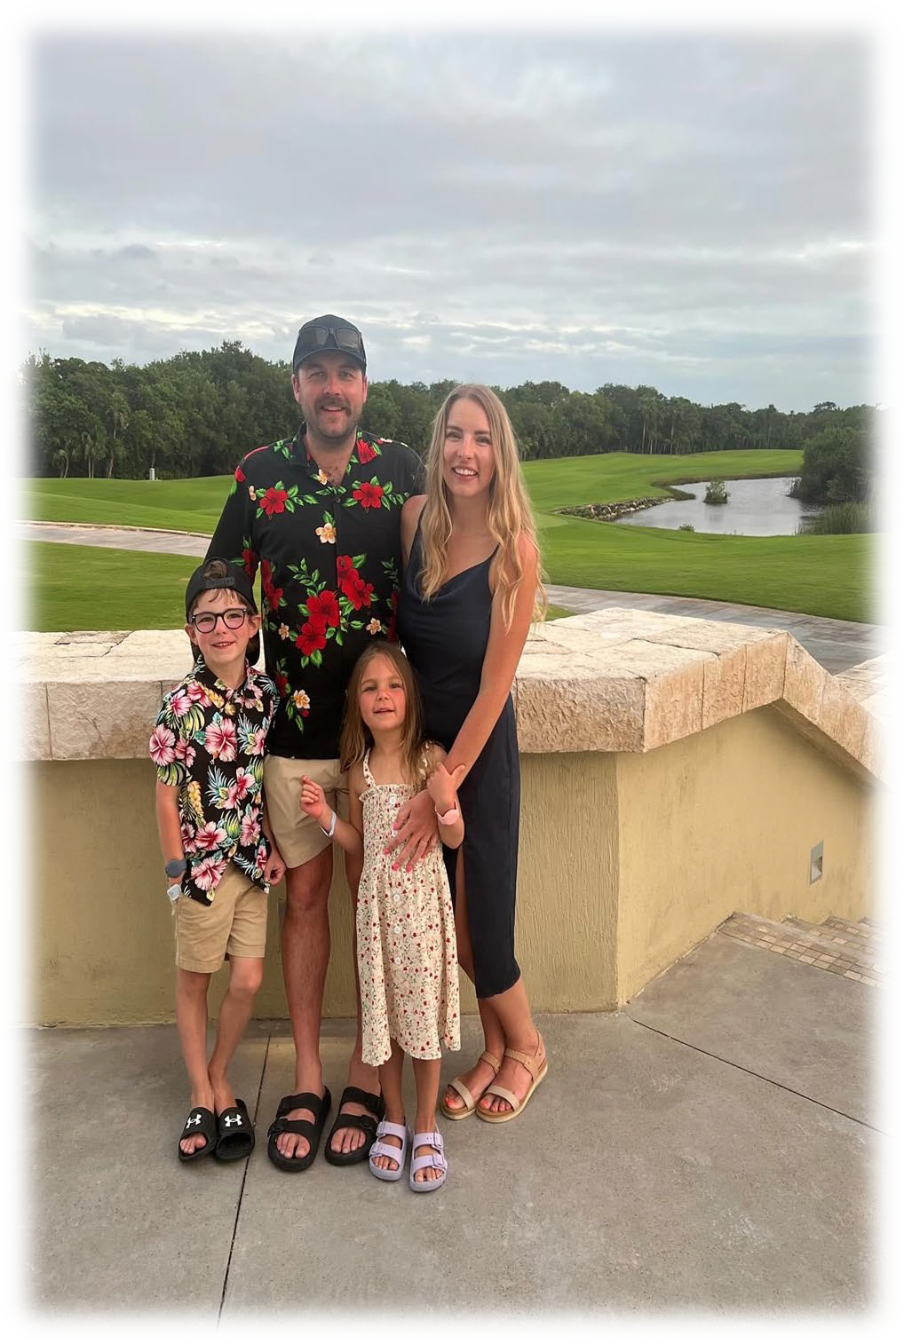
Dionne McCracken – Executive Chair of the School Council Board

Hello! My name is Dionne McCracken, and I am honored to serve as the Executive Chair of the School Council Board for another exciting year at SPT. I reside in the vibrant town of Taber with my husband Cole and our two wonderful children: Brigs, a Grade 2 student in Mr. De Coste's class, and Collins, who is enjoying her Kindergarten experience with Mrs. Ausmus. As a sports enthusiast, our family actively participates in a variety of activities, including hockey, baseball, dirt biking, gymnastics,soccer and trail riding. My educational background includes a diploma in Special Needs, and I currently work as a Licensed Realtor in Southern Alberta. In addition to my role at SPT, I am also involved with the Taber Minor Hockey Board and the Taber Highlanders Board. I am looking forward to my second year as Chair and am eager to collaborate with everyone for a fantastic year ahead!
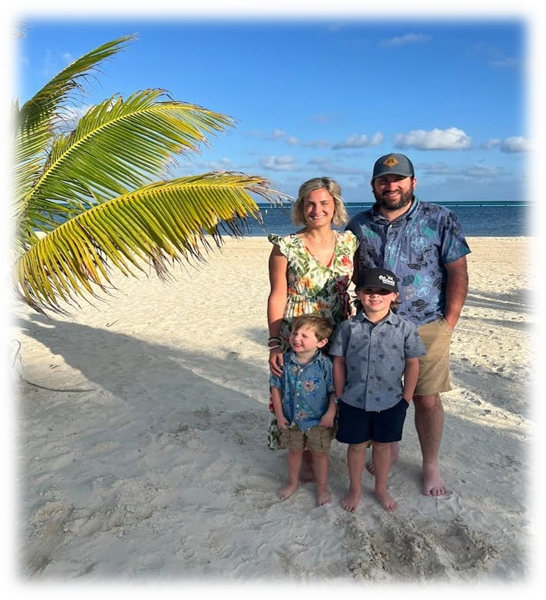
Codi Gouw -Vice Chair of the School Council Board

Hello!
My name is Codi Gouw. This is my second year on the SPT school council. I am excited for my new role on the executive board as Vice-Chair. I live on a farm outside of Taber with my husband Taylor and our two boys; Grayson who is 7 and Callen who is 4. We are a busy sports family and spend our extra time outdoors!

I work for Baker Hughes as an office administrator.

I am excited for another great year!

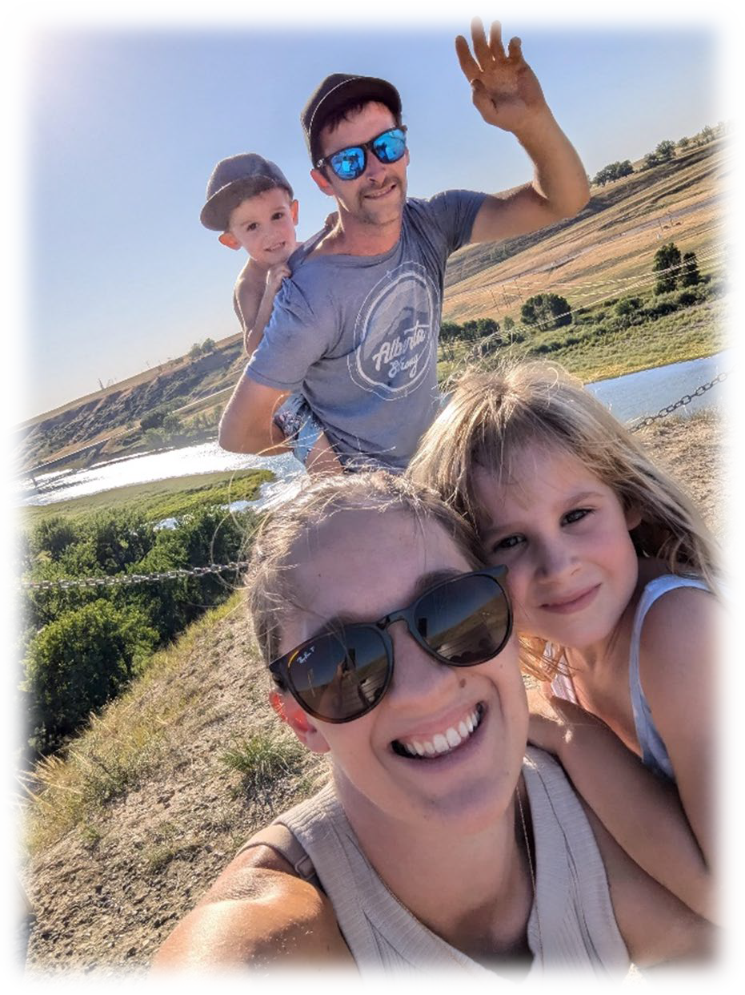
Karly Woof – Treasurer of the School Council Board

Hi! My name is Karly Woof and I will be your l School Council Treasurer. I am very excited for my role on school council and everything we get to be apart of this school year. My husband, Allan and I have two children. Our daughter, Kali who is in kindergarten and our son, Jett who is in Pre-K! We love to camp and spending our time outdoors. I am a Chartered Professional Accountant and work full time at a MNP in Taber. I love being able to be a part of the community and can't wait to see what the year will bring at SPT!

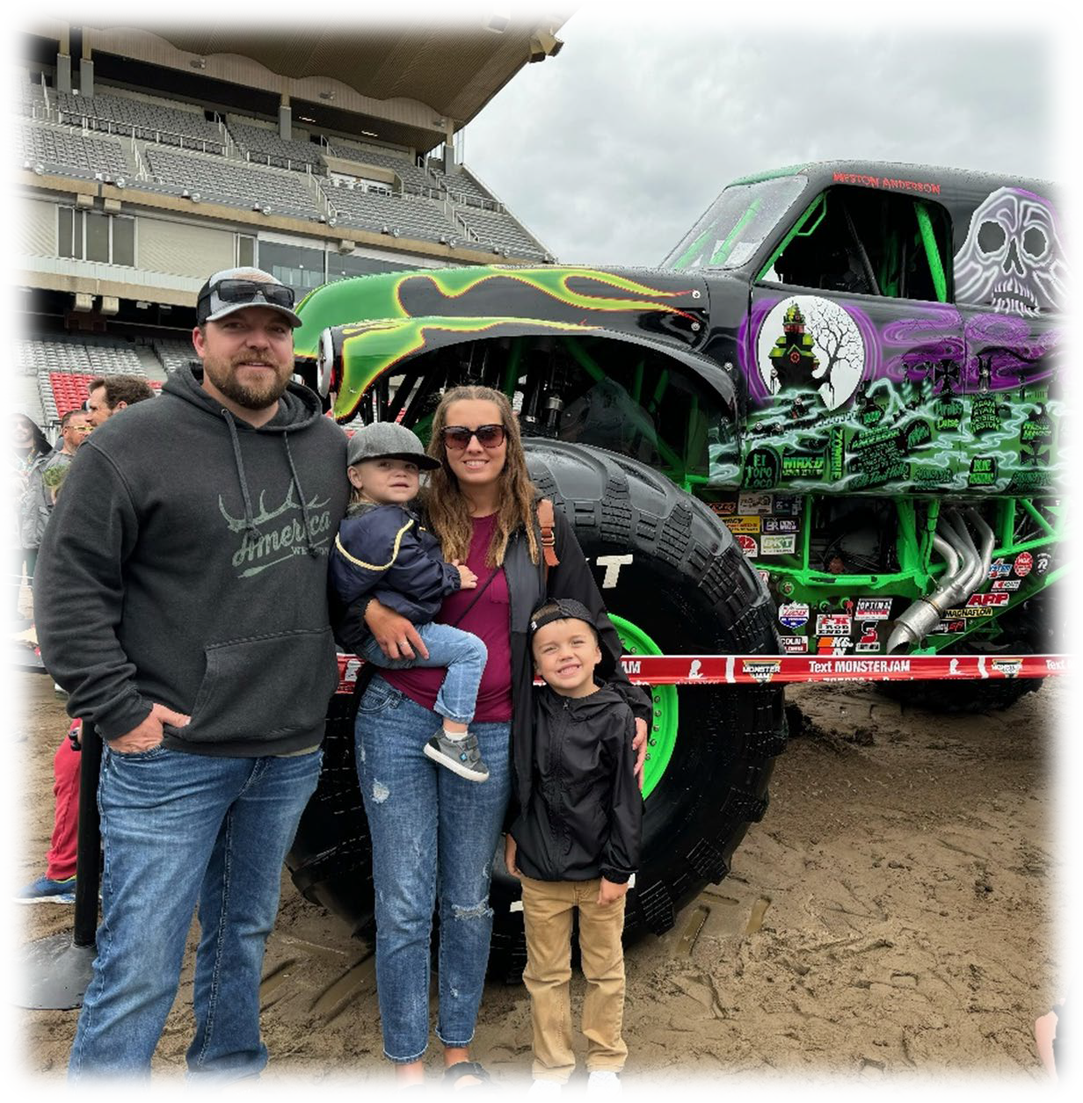
Kasey Petrie – Secretary of the School Council Board

Hey! My name is Kasey Petrie. This is my second year on SPT student council and I sit on the executive board as Secretary. I grew up in Taber and have stayed here to raise my own family. I live on an acreage outside of Taber with my husband Corey and our two boys; Rowen (5) and Wyatt
(2). We love to do anything outdoors; camping, boating, ATV and much more! My background is spent in Early Childhood Education and have been a part of boards in the community. I am excited for the year ahead!

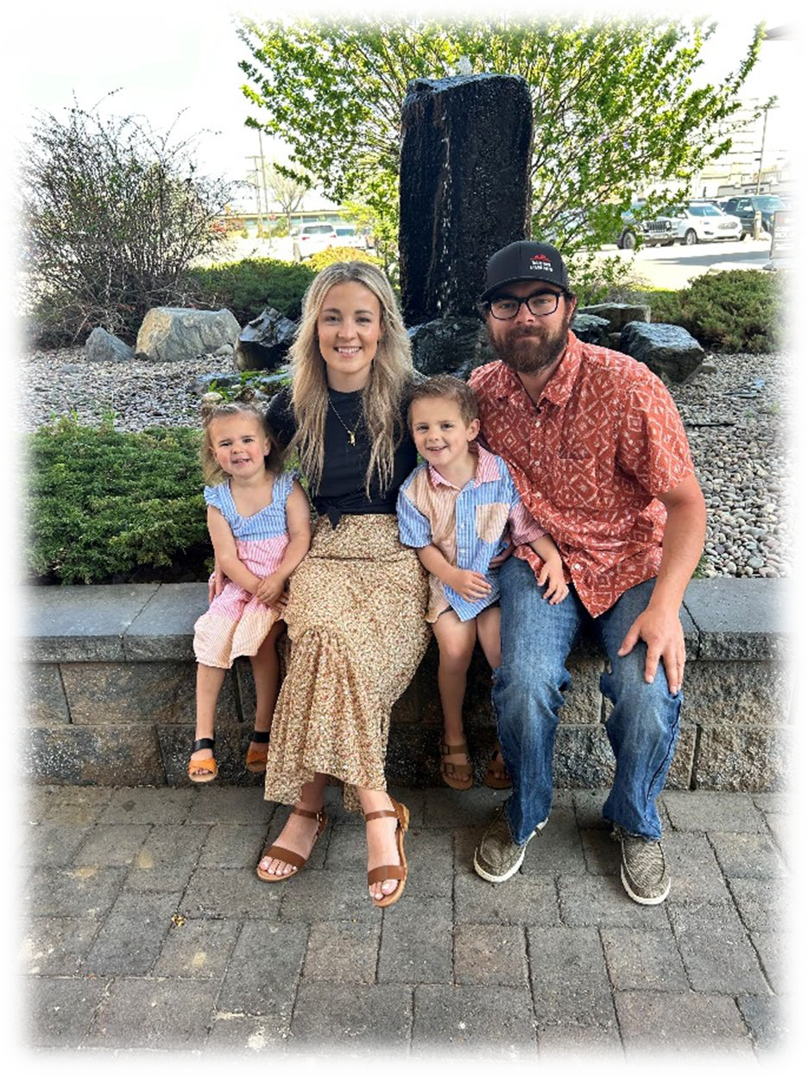
Cayden Turcato – Fundraising Coordinator of the School Council Board

Hi! My name is Cayden Turcato. I’m excited to have taken on a new roll on the board as the fundraising coordinator.
My husband Travis and I have two kiddos, Everett is in kindergarten and Lennox is in her second year of Pre-k! We feel so lucky to be apart of the SPT family.
Besides being a mom & a farm wife I work part time at the clinic. We love spending our free time together and usually doing something outside.
I can’t wait to see what this year brings for our school!

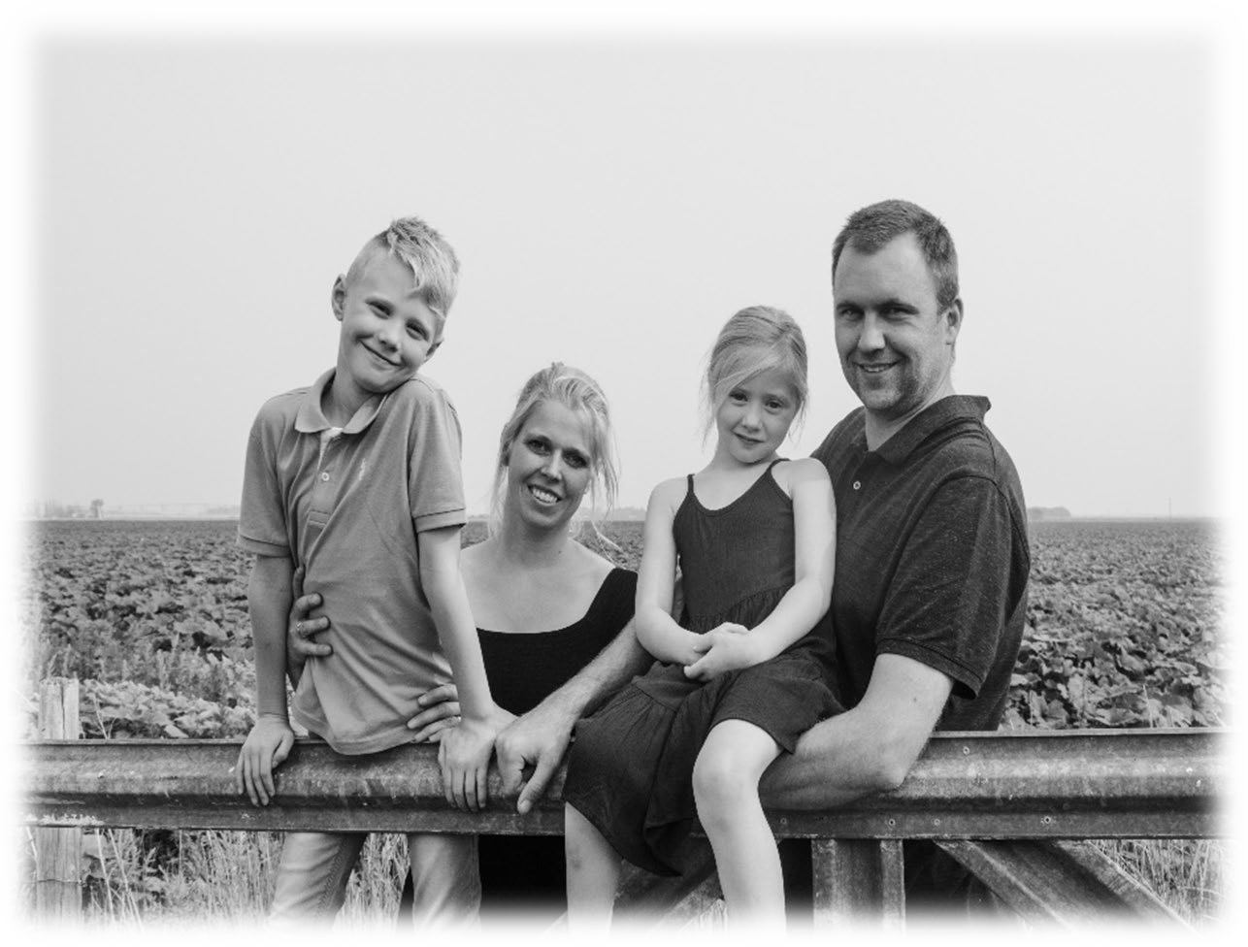
Hi, my name is Diana Michielsen,
I help out where I can for the second year at the School Council.
And I love to be a part of it!
My husband Frank and I have two kids, Oliver and Alice, and we live just out of town.
We have a couple of sheep and cats to keep us company when we are home. We are a busy, work-related family, and you can find us all a lot at PGS Equipment Ltd.
We love to spend slower time in the winter to catch up on family activities.

Best regards, Diana Michielsen

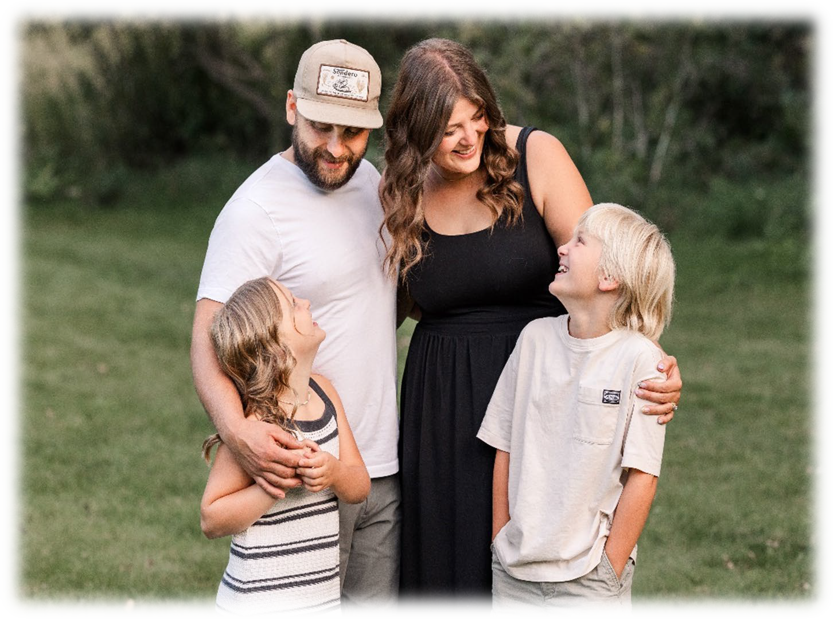
Verna Fehr here, surviving marriage to Cornelius Fehr with two mini-mes: Zeke, rocking grade 3 with Mr. DeCoste, and Emberly, keeping Ms. Mabins grade 2 class entertained. My therapy includes sewing, reading, and organizing shindigs, all while keeping my Coulee Clinic gig.

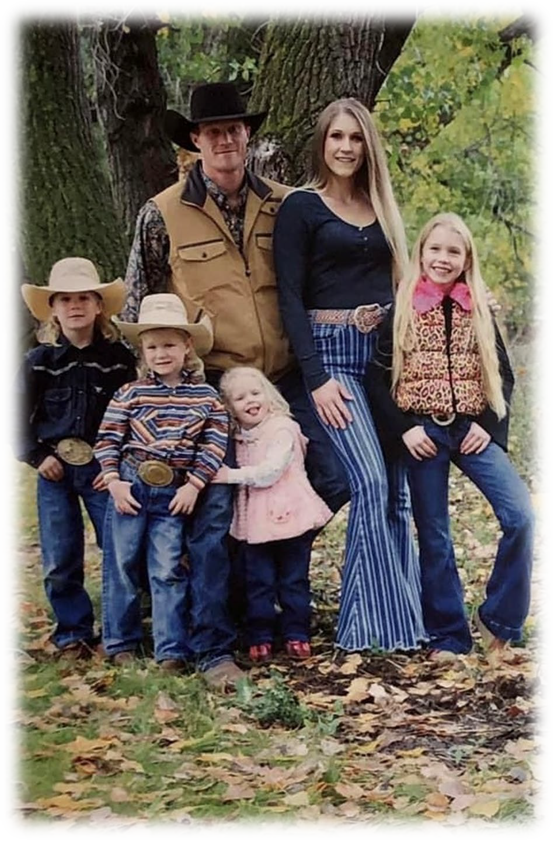
Hi, my name is Mackayla Hudson, I am a member of the School Council Board. I reside in the town of Taber with my husband Jeff and our four kids; Layla (Grade 4), Keelan (Grade 3), Stetson (Kindergarten) and Maci (1st year Pre- K). We are a very busy sports enthusiastic family, who can usually be spotted at the Hockey arena, Gymnastics Club and Baseball Diamonds. I have my Certificate as a Veterinary Technical Assistant, which I enjoyed working as for multiple years. However, I am very blessed and excited to be on a new journey as part of the Holy Spirit Catholic School Division currently working as a casual education assistant. I am also a board member with the Taber Competitive Gymnastics Parent Association and the Taber Minor Hockey Association. I am very excited to join this amazing group of parents and embark on a funtastic year at SPT.

Mackayla Hudson

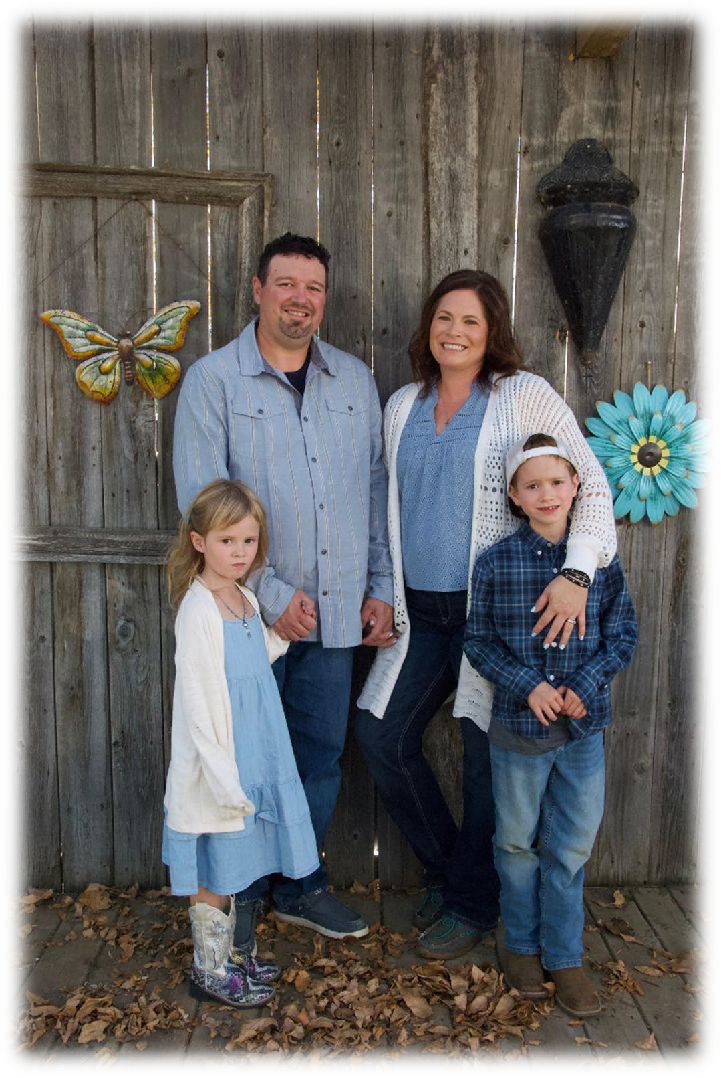
"Hi SPT Family!

My name is Amanda Feldbusch and I will be helping out with the School Council this year. I am pumped to work with our community and help where I can. I was born and raised in Taber and at that time attended SPT. My husband, Cody, and our two kiddos we reside just outside of Taber. Cooper is 8 and in grade 2/3 with Mrs. Gutfriend and Samantha is 6 and in Grade 1 with Miss Wiest. As a family we enjoy everything from hockey to camping to rodeo/horse riding. Who doesn't love some fresh air!

During the week you can find me at ATB Financial where I am an Agricultural Relationship Manager in the South part of the province. I have enjoyed helping producers for almost 15 years. As well I have been on the board for the Taber Exhibition Association for the last couple years and going into my third year. I truly enjoy helping our small community.

I am looking forward to being part of your School Council and can't wait to meet everyone. Here is to a great 24/25 School Year!!"

